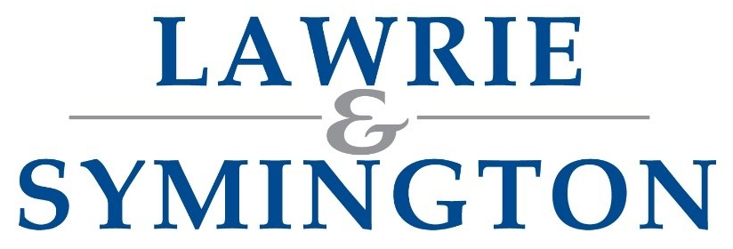

**Opportunities- Office Staff**

Lanark

**Outline**

Lawrie & Symington are recruiting office staff to join our auction market team at Lanark Agricultural Centre.

The position(s) will cover all aspects of office and accounts admin with direct contact with customers & suppliers.

**Requirements**

The successful candidate(s) will be a team player with the ability to use their own initiative, demonstrating excellent communication skills, both written & verbal and have the ability to multitask in a fast-paced work environment.

IT skills are essential as is a good working knowledge of Microsoft Word & Excel. Training will be given on our bespoke software.

Knowledge of the livestock industry would be advantageous but not essential.

To apply send a copy of your CV with covering letter to:

[jamie@lawrieandsymington.com](mailto:jamie@lawrieandsymington.com)