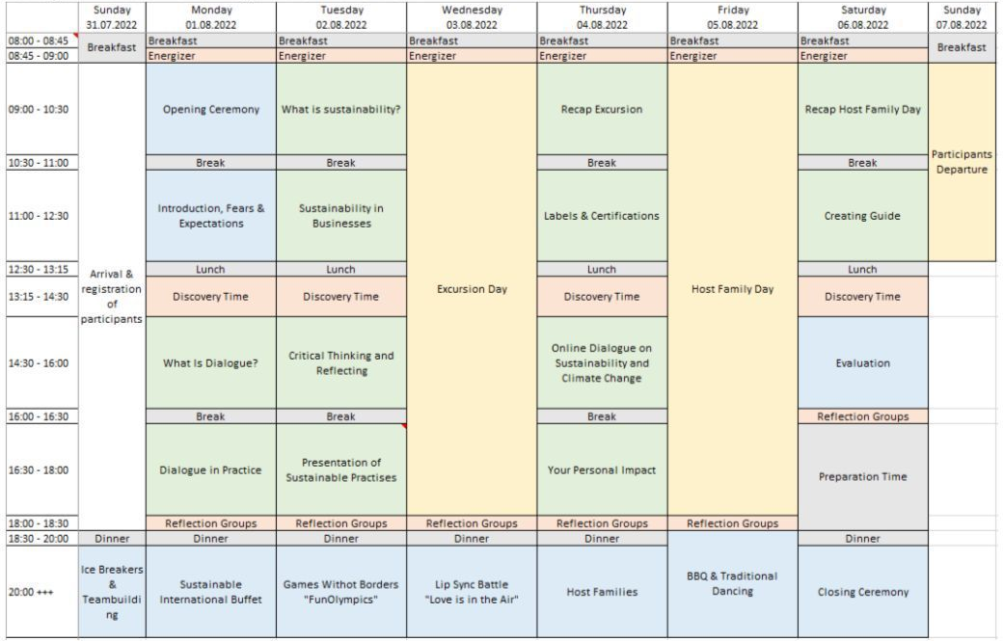
The timetable below represents the schedule for the rally with the theme of: Shaping Future Dialogue for Sustainability in Rural Areas

The timetable below represents the schedule for the rally with the theme of: Planting Ideas, Cultivating the Future
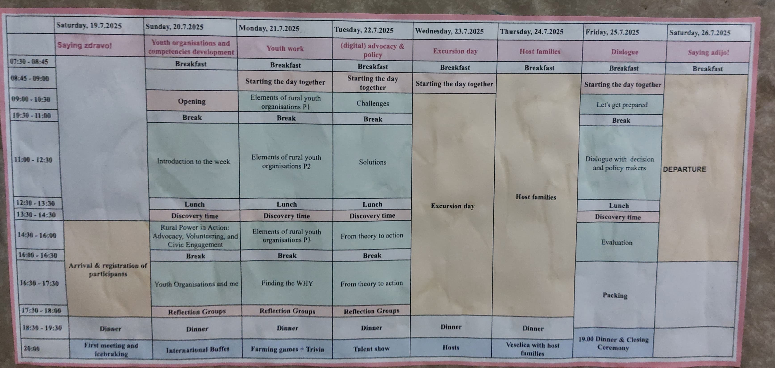

Areas

